Software Requirement Specifications
Student Result Management



Submitted by
Syed Muhammad Shahzil (S23BINFT1M01067)

Submitted to
Mr. Ali Nawaz Shah

Department of Information Technology
Faculty of Computing
The Islamia University of Bahawalpur

Meeting Details
Sr No | Details | Date | Supervisor Signature
Summary
The Student Result Management System (SRMS) is a school-focused, centralized information system designed to manage student academic results in a structured and automated way. In many schools, result handling (recording marks, calculating totals/grades, maintaining records, and publishing results) is often done manually or across multiple files, which can lead to delays and errors. SRMS addresses this by providing a single platform where result-related data can be entered, processed, stored securely, and retrieved when needed.

Table of Contents

1. Introduction 5
1.1. Purpose 5
1.2. Scope 5
1.3. Product Perspective 5
1.4. User Characteristics 5
1.5. Similar apps and systems/Literature Review 6
1.6. Proposed Technologies 7
2. Requirements 7
2.1. Function Requirements 8
2.1.1. Registration 8
2.1.2. Manage Result 8
2.1.3. View Result/Profile 8
2.1.4. Profile Management 8
2.2. Non-Functional Requirements 9
3. Use Cases and Flow of Processes 10
4. References 18

- Introduction
  - Purpose
The Student Result Management System (SRMS) is designed to provide a centralized and efficient platform for managing student academic results within a school. Its purpose is to automate key result-related tasks such as result entry, calculations/processing, secure storage, retrieval, and publication. By replacing manual or scattered record-keeping methods, SRMS helps reduce errors, saves time for teachers and administrators, and ensures that academic information is accurate, secure, and available when needed to authorized users.
  - Scope
The scope of SRMS covers the complete workflow of result management in a school environment. This includes registering students and teachers, authenticating users (login/logout), managing user profiles (create/update/delete), entering and managing student marks/results, and publishing results for viewing. The system supports multiple academic classes/levels and enables different user roles—administrators, teachers, and students—to interact with the system according to their permissions. Overall, SRMS focuses on handling result-related activities from initial data creation to final result display in a consistent and user-friendly manner.
  - Product Perspective
SRMS is a school management support product that primarily focuses on the academic results module while also linking with basic school data such as student and teacher profiles. It serves as a digital replacement for manual registers and spreadsheet-based result records by providing one unified system for result handling. Through role-based access (Admin, Teacher, Student), SRMS improves transparency and communication: administrators can manage users and results, and students/teachers can view profiles and results. The product is intended to be accessible through a compatible web browser on common devices (mobile and PC), making it practical for school operations and remote access where internet connectivity is available.
  - User Characteristics
The Student Result Management System (SRMS) will be used by multiple types of users with different responsibilities and technical skill levels. The system is therefore designed to be simple, role-based, and easy to learn.
- Administrator(Admin):
The admin is the primary manager of the system. Admin users are responsible for registering students and teachers, managing user profiles (create/update/delete), and managing/publishing student results. Admin users are expected to have basic computer and internet skills and may require access to advanced options (user management, result management, updates). They need reliable system performance, strong security, and clear control over data.
- Teachers:
Teachers will use the system mainly to access their profiles and view student-related academic information (as defined in the SRS). Teachers are expected to have moderate technical skills and limited time, so the system must support quick navigation, clear screens, and minimal steps to view required information. A user-friendly interface is important to reduce training needs.
- Students:
Students are end users who will log in to view their profiles and results. Their technical skills can vary widely, so the system must be highly intuitive and mobile-friendly. Students require quick access, accurate result display, and privacy of their personal and academic records.

  - Similar apps and systems/Literature Review
Many schools currently manage results through manual registers, Excel sheets, or basic school management applications. While these methods can work, they often create common problems such as duplicate records, calculation mistakes, difficulty in updating results, delayed publication, and limited accessibility for students.
Similar systems (e.g., general School Management Systems, Learning Management Systems, and online result portals) usually provide features like user authentication, student/teacher profiles, result/grade management, and result reporting. These systems highlight key best practices relevant to SRMS:
- Centralized database storage to avoid scattered records and improve data consistency.
- Role-based access control to ensure privacy and prevent unauthorized changes.
- Automation of calculations and result processing to reduce human error.
- Online result publishing so students can access results quickly.
- Usability and responsiveness to support access on both mobile and desktop devices.
The SRMS is proposed as a focused result management solution that follows these established practices while keeping the interface simple for school users.

  - Proposed Technologies
Student Result Management System (SRMS) is developed using modern and reliable web-based technologies to ensure efficiency, security, and scalability. The system is implemented with PHP for server-side scripting and backend business logic, while MySQL (SQL) is used as the database management system to securely store and manage student, teacher, and result records.
The front-end of the application is built using HTML, CSS, and JavaScript to provide an interactive, responsive, and user-friendly interface for administrators, teachers, and students. A REST API is used to enable smooth and structured communication between the frontend and backend components, supporting efficient data exchange and modular development.
To ensure secure operation, SSL encryption is implemented to protect data during transmission over the network. Additionally, LDAP authentication is used for secure user login and to support role-based access control, ensuring that users can only access features and data authorized for their role (e.g., admin, teacher, student).
For quality assurance, Selenium is used for functional and automated testing to validate user workflows and system behavior. Apache JMeter is used for performance and load testing to verify system stability and responsiveness under concurrent usage. The system also supports exporting records and reports in CSV and PDF formats to facilitate reporting, offline record keeping, and easy sharing of academic results.

- Requirements
  - Function Requirements
    - Registration
Identifier | Reg-1
Title | Registration ]
Requirement | Enable new Stu/Teachers to be admitted.
Source | Registration
Priority | High Priority

    - Manage Result
Identifier | Res-1
Title | Manage result
Requirement | Allow students result to be displayed on the system.
Source | Manage result module
Priority | High priority

    - View Result/Profile
Identifier | Vp-1
Title | View profile/Result
Requirement | The user should be enabled to views their profile and their results.
Source | View profile and view result module
Business rule | User must be logged in.
Priority | High

    - Profile Management
Identifier | Pm-1
Title | Profile management
Requirement | Enable admins to create/update/delete user profiles.
Source | Manage profile module
Business rule | Admin must be logged in to view their profiles.
Priority | High

  - Non-Functional Requirements
Usability

UR1: Intuitive User Interface
The SRMS should feature an intuitive user interface that is easy to navigate, facilitating efficient use by administrators, teachers, and students without extensive training.
UR2: Accessibility
The system must comply with accessibility standards (such as WCAG) to ensure that individuals with disabilities can access and interact with the SRMS without barriers.
UR3: Mobile Responsiveness
The SRMS should be responsive to various screen sizes, ensuring optimal user experience on devices such as laptops, tablets, and smartphones.
UR4: User-Friendly Result Entry
The result entry process must be user-friendly, allowing teachers and administrators to input student grades, comments, and other relevant information with ease.
UR5: Personalized User Profiles
Users, particularly students, should have personalized profiles displaying relevant academic information, making it easy to track individual progress.
UR6: Notification System
The SRMS should feature a notification system that informs users of important updates, such as result publications or system announcements.

Performance

PR1: Response Time
The system must respond to user interactions within a maximum of 2 seconds to ensure a seamless and efficient user experience.
PR2: Concurrent Users
The SRMS should support a minimum of 100 concurrent users without significant degradation in performance during peak usage times.
PR3: Result Processing Time
Result processing, including calculations and updates, should be completed within 5 seconds per student to ensure timely and efficient handling of academic data.
PR4: System Availability
The SRMS should maintain a 99.5% uptime, allowing users to access the system at any time during operational hours.
PR5: Scalability
The system should be scalable to accommodate a 20% growth in student enrollment over the next five years without compromising performance.
PR6: Data Retrieval Speed
Retrieval of student academic records, including grades and attendance, should be completed within 3 seconds to provide quick access to information.

- Use Cases and Flow of Processes

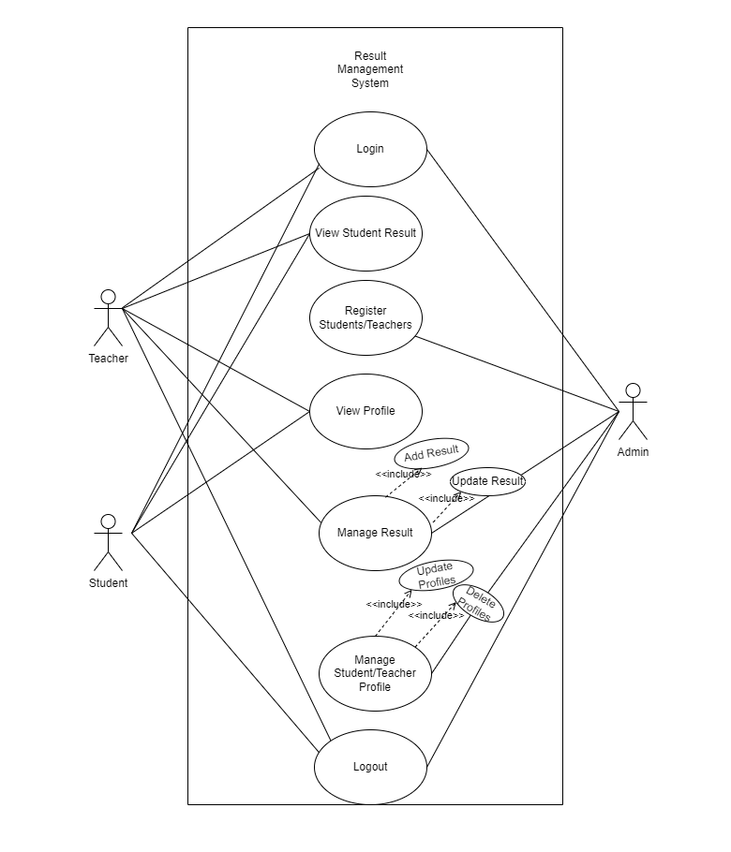

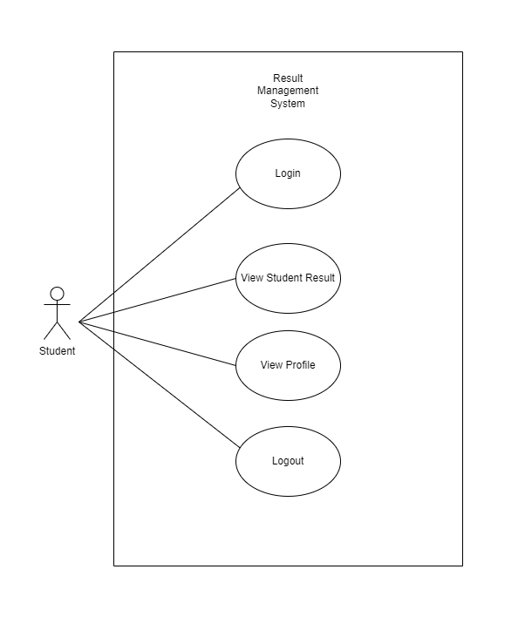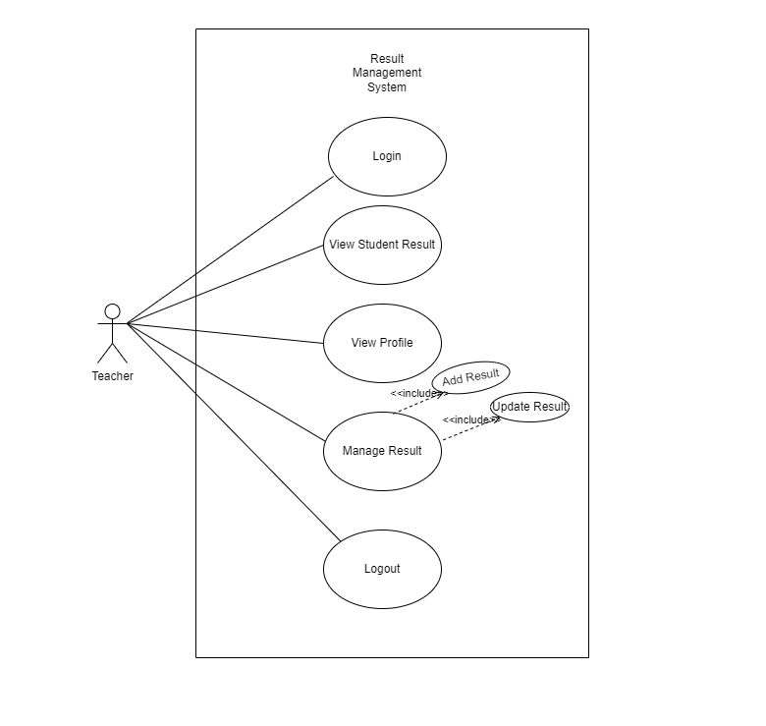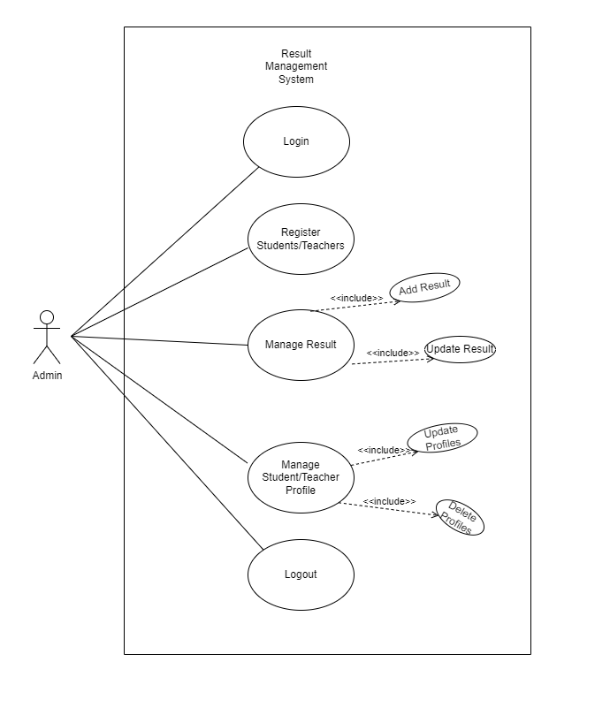

3.1 Use case description

Use Case ID: | Log-1
Use Case Name: | Login
Actors: | Primary Actor: User
Description: | This use case is about login of Customer
Trigger: | The User indicates the intention to log into the system.
Preconditions: | The User is saved in schools database
Postconditions: | The user is logs into the system
Normal Flow: | It allows user capture information from user right after they enter user name and password, the site is able to access.

Use Case ID: | Reg-1
Use Case Name: | User Registration
Actors: | Admin
Description: | Admit new students or teachers to school.
Preconditions: | The new user is not registered before.
Postconditions: | Student/Teachers’s profile is created.

Use Case ID: | Res-1
UseCase Name: | Manage Result
Actors: | Admin
Description: | School displays the result.
Preconditions: | The admin is logged into the system.
Postconditions: | Each student result is added.
Business Rules | Result should not be negative.

Use Case ID: | UC-4
UseCase Name: | View Profile
Actors: | Student/Teacher
Description: | User can view their profile where their information is stored.
Trigger: | User wants to have a look at their profile
Preconditions: | User should be logged in.
Postconditions: | Profile is displayed.

Use Case ID: | Pro-1
Use Case Name: | Manage profiles
Actors: | Admin
Description: | A student/Teacher may be removed , or their related information may need to be updated.
Preconditions: | The admin is logged into the system.
Postconditions: | The profiles are managed.

Use Case ID: | Log-2
Use Case Name: | Logout
Actors: | Stu/Teacher
Description: | The user wants to logout of the system.
Trigger: | The user indicates the intention to logout.
Preconditions: | The user is logged into the system.
Postconditions: | User is logged out.

- References
- Software Requirements — Book by Joy Beatty and Karl Wiegers
- Wikipedia — https://www.wikipedia.org/
- Google — https://www.google.com/
- Visual Paradigm (for diagrams) — https://www.visual-paradigm.com/
- PHP Documentation — https://www.php.net/docs.php
- MySQL Documentation — https://dev.mysql.com/doc/
- Selenium Documentation — https://www.selenium.dev/documentation/
- Apache JMeter Documentation — https://jmeter.apache.org/

